CSCE 310 Project Report

Members:

Jace Thomas

[Semion Dyadkin](mailto:d1101011@tamu.edu)

[Trevor Underwood](mailto:trevor012@tamu.edu)

[John Nolen](mailto:jdnolen@tamu.edu)

ERD Changes:

Original ERD:

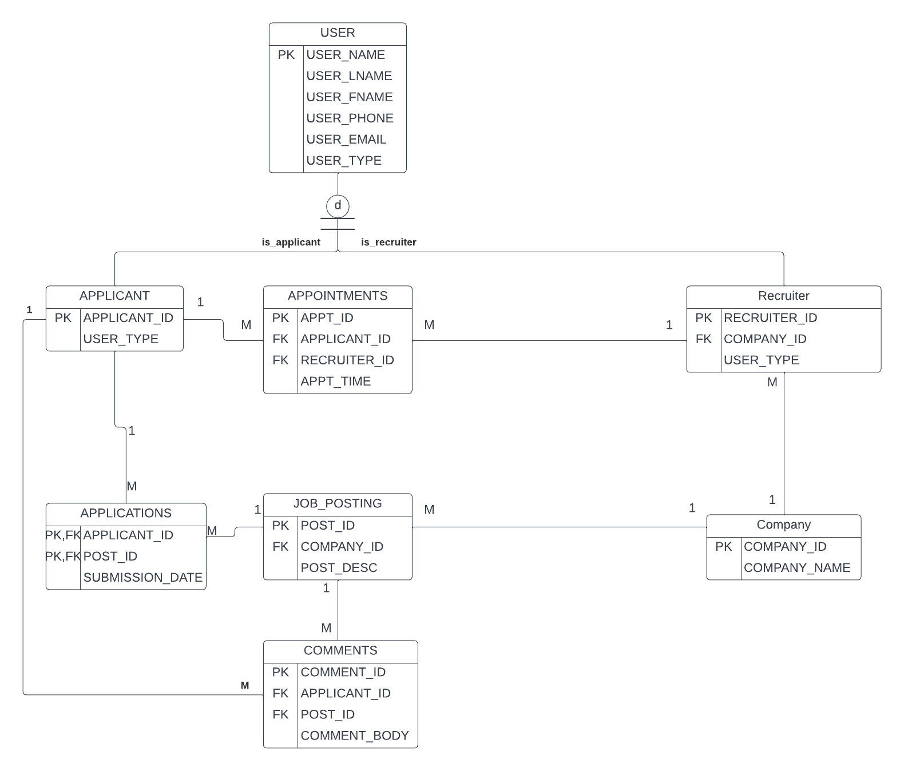

New ERD:

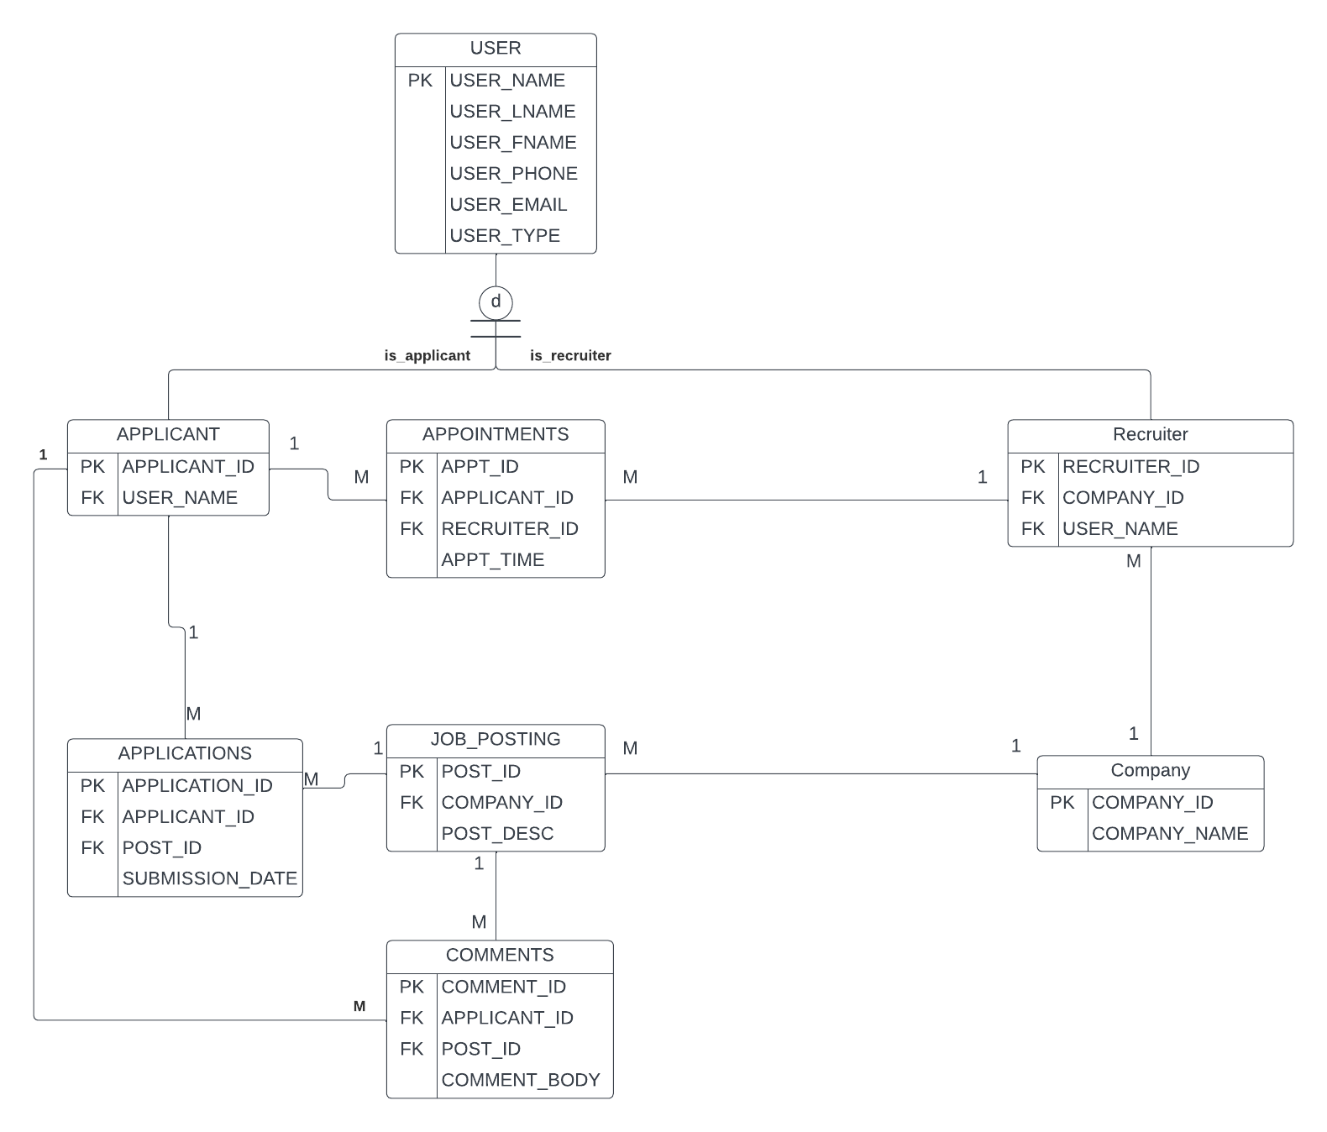

There were only slight changes to our ERD. In the applications table, we created a stand alone primary key, “Application_ID '', as the old version of the table violates 3NF format. We also included the foreign key “USER_NAME” from the user table, in applicant and recruiter so we could link the tables together properly. Other than these minor changes the ERD was not modified.

Team Member File Contributions:

Jace Thomas:

* App.php
* Application.php
* Create_post.php
* Delete_application.php
* Delete_post.php
* Edit_application.php
* posting.php

Trevor Underwood:

* login.html
* login.php
* appointments.php
* create_appointment.php
* edit_appointment.php
* delete_appointment.php

John Nolen:

* user_profile.php
* create_user.php
* delete_profile.php
* edit_profile.php

Semion Dyadkin:

* comments.php
* Delete_comment.php
* Edit_comment.php
* add_comment.php

Team Member Functionality Sets:

Jace Thomas:

* Applications:
  + Applicants can create applications on job postings
  + Applicants can view their applications
  + Applicants can edit their applications
  + Applicants can delete their applications
  + Recruiters can view applications to their company
  + Recruiters can schedule appointments from applications
* Job Postings
  + Applicants can view job postings
  + Applicants can apply directly from job postings
  + Recruiters can view job postings
  + Recruiters can create job postings
  + Recruiters can remove job postings

Trevor Underwood

* Appointments:
  + Applicants can create an appointment
  + Applicants can view their appointments for their APPLICANT_ID
  + Applicants can edit their appointments
  + Applicants can delete their appointments
  + Applicants can see their view for their appointment time with their APPLICANT_ID
  + Recruiters can create an appointment
  + Recruiters can view their appointments for their RECRUITER_ID
  + Recruiters can edit their appointments
  + Recruiters can delete their appointments
* Login:
  + Applicants can log in with their username
  + Recruiters can log in with their username

John Nolen

* Create New User:
  + New Users can create a new account
  + Some common data is collected for all users (name, phone, email, etc.)
  + Users may specify between the Applicant and Recruiter user type for their account
  + Recruiters are prompted to also provide the name of the company they are affiliated with
* User Profile
  + Users may view all of their data in their profile page
  + Users may update certain attributes on their profile page (e.g., phone, email, etc.)
  + A User may delete their profile, which removes all data related to the specific User from all tables in the database

Semion Dyadkin

* Comments
  + Applicants can view a job posting’s comments
  + Applicants can edit their comments
  + Applicants can delete their comments
  + Applicants can create comments
  + Recruiters can view comments